**DAILY ONLINE ACTIVITIES SUMMARY**

|  |  |  |  |  |  |  |  |
| --- | --- | --- | --- | --- | --- | --- | --- |
| **Date:** | **06 June 2020** | | | | **Name:** | **KHATHEEJA SAFREENA** | |
| **Sem & Sec** | **4th sem, 2nd year** | | | | **USN:** | **4AL18CS037** | |
| **Online Test Summary** | | | | | | | |
| **Subject** | | **DATA COMMUNICATION (18cs46)** | | | | | |
| **Max. Marks** | | **30** | | **Score** | | **25** | |
| **Certification Course Summary** | | | | | | | |
| **Course** | **MARKETING FOUNDATION.** | | | | | | |
| **Certificate Provider** | | | **Great Learning** | **Duration** | | | **5hrs** |
| **Coding Challenges** | | | | | | | |
| **Problem Statement:2 program** | | | | | | | |
| **Status: Executed** | | | | | | | |
| **Uploaded the report in Github** | | | | **Yes** | | | |
| **If yes Repository name** | | | | **[http://shafreenasharief / lockdown-coding](http://shafreenasharief / lockdown-coding" \o "http://shafreenasharief / lockdown-coding)**  **[http://shafreenasharief / locked-down--certification-course](http://shafreenasharief / locked-down--certification-course" \o "http://shafreenasharief / locked-down--certification-course)**  **[http://shafreenasharief / Daily\_Report](http://shafreenasharief / Daily_Report" \o "http://shafreenasharief / Daily_Report)** | | | |
| **Uploaded the report in slack** | | | | **Yes** | | | |

Online Test Details: (Attach the snapshot and briefly write the report for the same)

Certification Course Details: (Attach the snapshot and briefly write the report for the same)

Coding Challenges Details: (Attach the snapshot and briefly write the report for the same)

**ONLINE TEST SUMMARY:**

Today **DATA COMMUNICATION (18cs46)** was conducted for Total 30 marks

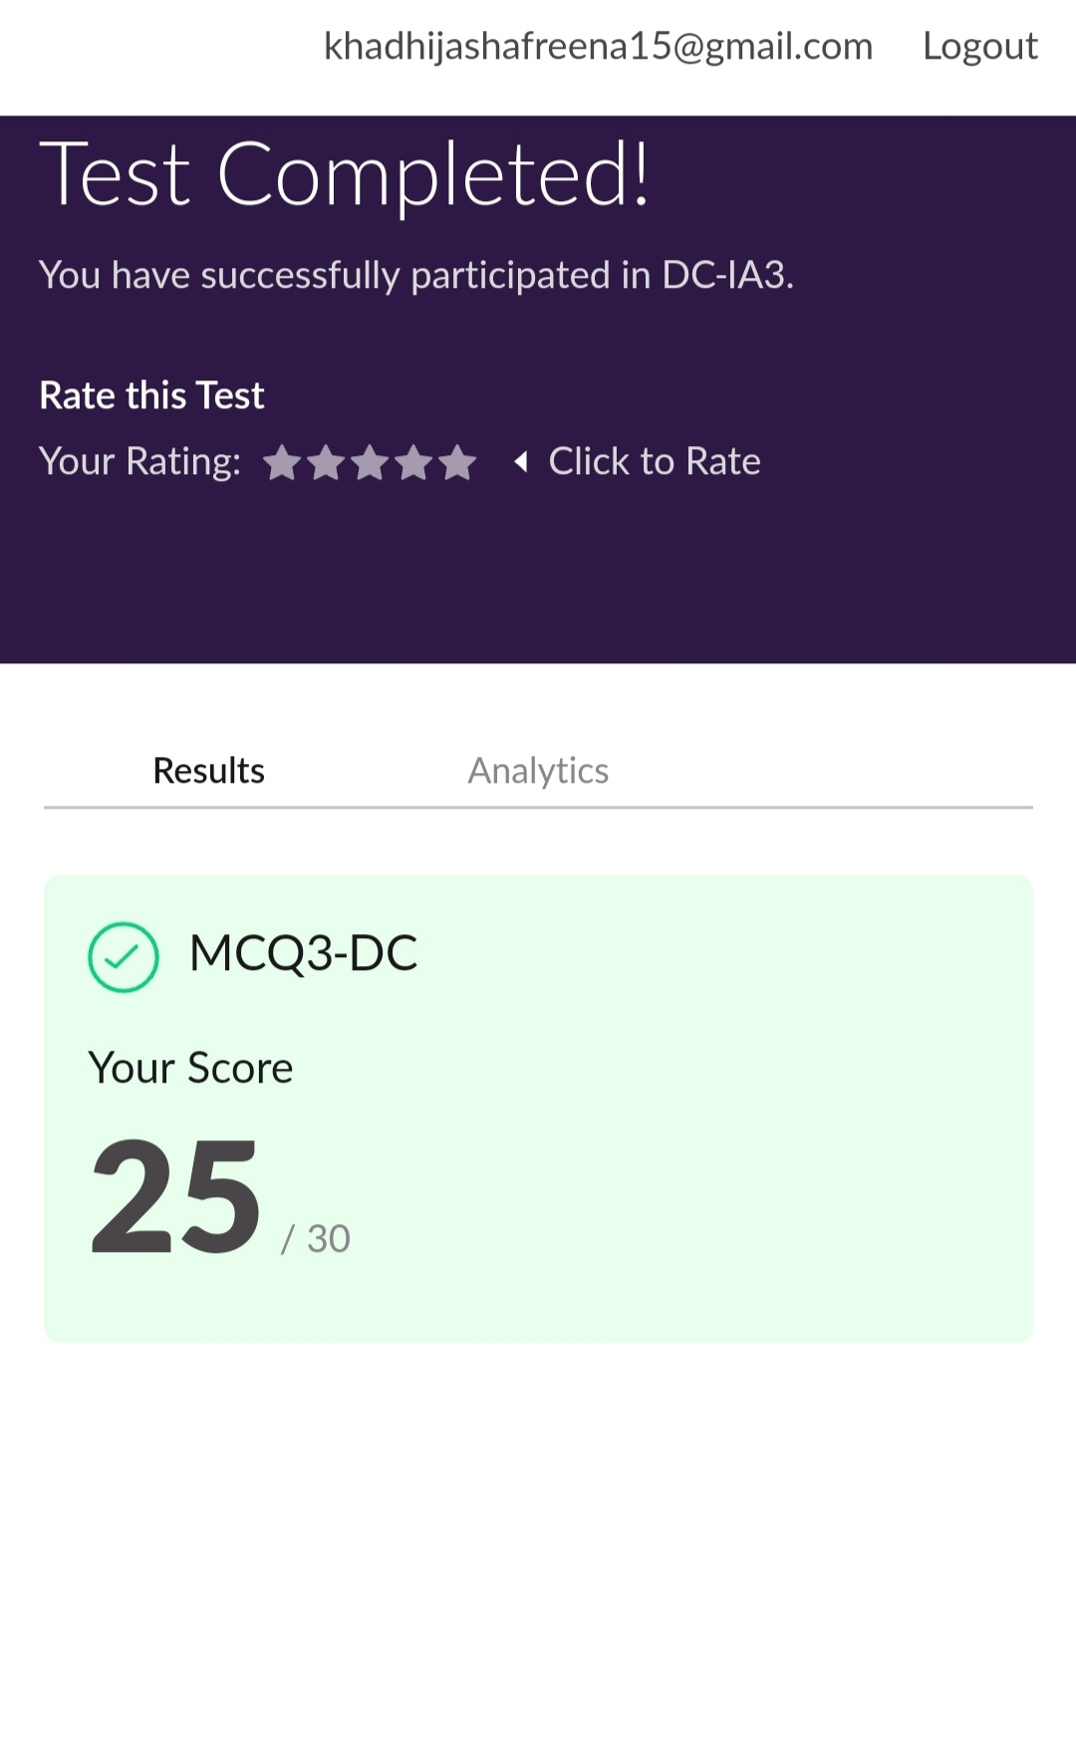

**CERTIFICATION COURSE SUMMARY:**

Today I started certificate course on '**MARKETING FOUNDATION**', through GREAT LEARNING.The course was scheduled for 5 hrs .I completed 3 modules that are Introduction to marketing,Marketing mix and plan implementation.I attempted quiz ,which gave me a clear veiw about the topics that were thought and discussed.It consists of 10 modules which also include assessments.



**CODING CHALLENGE:**

Today I solved 2 coding challenge,

1.**Write a Java Program to find the second-highest number in an array**.

2. **Write a program in C to rotate an array by N positions.**

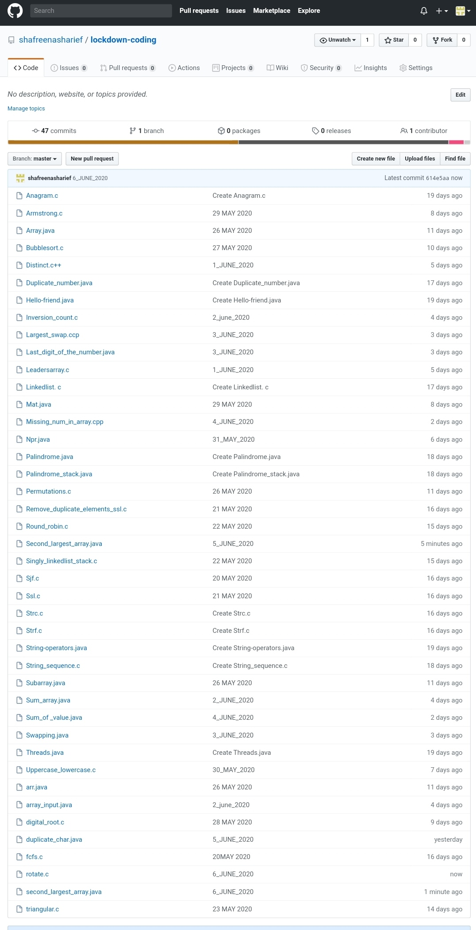

SOLUTION : I have uploaded the solution of the above 3 coding problems in my GitHub repository.

[http://shafreenasharief / lockdown-coding](http://shafreenasharief / lockdown-coding" \o "http://shafreenasharief / lockdown-coding)

[http://shafreenasharief / locked-down--certification-course](http://shafreenasharief / locked-down--certification-course" \o "http://shafreenasharief / locked-down--certification-course)

[http://shafreenasharief / Daily\_Report](http://shafreenasharief / Daily_Report" \o "http://shafreenasharief / Daily_Report)